POLITICAL & ECONOMIC RISK CONSULTANCY LTD
ASIAN INTELLIGENCE
No. 701 Wednesday March 1, 2006
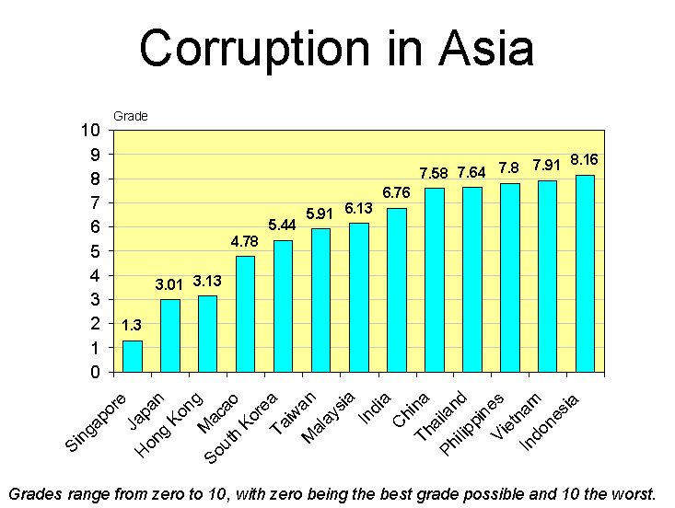
REGIONAL OVERVIEW
CHINA
HONG KONG
INDIA
INDONESIA
JAPAN
MACAO
MALAYSIA
PHILIPPINES
SINGAPORE
SOUTH KOREA
TAIWAN
THAILAND
VIETNAM
EXCHANGE RATES ON 2/24/06

REGIONAL OVERVIEW

Corruption trends in Asia
This is our annual report assessing corruption trends in Asia. There is a lot of information to digest, so we will let the raw figures do the talking in the country-specific sections of this report, while confining our written analysis to this regional overview. Between January and the February 24th we received more than 1,200 replies to a mail survey and face-to-face interviews we conducted of expatriates working in Asia. In most countries we received around 100 replies, although the sampling size was smaller in Macao and Vietnam (54 replies and 63 replies, respectively). In all cases respondents were asked to assess conditions in the country in which they were working as well as in their home country. This means that while it is interesting to make cross-country comparisons, this survey is more useful for evaluating how perceptions in any given country are changing over time.
There is some good news on the corruption front in Asia. Expatriate perceptions of the problem are improving in most countries. We have come to this conclusion through two measures. One is comparing this year’s to last year’s scores to the survey question: “How big is the problem of corruption in terms of its being a feature influencing the overall business environment?” The score showed an improvement in 10 of the 12 countries we surveyed for both years, while it deteriorated in only two of the countries surveyed.
The other measure that indicates expatriates perceive the problem of corruption to be lessening in more countries than it is worsening is a separate survey question. We specifically asked if respondents perceive the trend of corruption to be decreasing, staying the same, or increasing. In 11 out of the 13 countries we surveyed this year (for the first time we added Macao to the list) respondents indicated they felt the problem of graft is decreasing, while they pointed to a deteriorating problem in only two countries. One was Thailand. Here the trend was negative no matter which measure is used. In the case of the Philippines replies were more negative when respondents were asked about the trend, but this year’s survey score assessing the level of corruption is actually better than last year’s score. On the other hand, Singapore was graded worse this year than last when respondents were asked to provide a score for the level of corruption, but the same respondents who replied this year indicated that they felt the problem of corruption is decreasing in the Lion City. The perception trend in these countries is therefore less clear than in Thailand, where the problem of deteriorating corruption has been underscored twice.
Thailand’s case is special. Accusations of high-level corruption have been intensifying in recent months – to the point where they could affect political stability. The prime minister and his family company, Shin Corp., are at the center of many of the controversies, as evidenced by the recent uproar over his family’s 73.3-billion baht sale of its controlling stake in Shin Corp. to a Singapore state-owned company. Critics of Mr. Thaksin accuse him of amending a law on foreign ownership of Thai telecom firms so his family could benefit from the completion of the deal. The government’s defense is that: “The law was amended to encourage foreign investment, not to favor the prime minister’s family.”
Such is the problem of corruption – not just in developing countries, but also in developed ones like the US and in multilateral organizations like the World Bank. When it gets high enough in the political process, the legal system and the legislative institutions responsible for passing laws can be co-opted to the point where they are a central part of the problem. The line between corruption and legal legislative change can be very blurry. Just look at the recent lobbying scandal in the US involving Jack Abramoff. This is about a system of corruption in which elected figures of all major parties are involved. As the Financial Times wrote in its January 17 editorial on this scandal: “Nowhere else in the civilized world is it so widely accepted that money buys access and influence over policy and that interest groups must ‘pay to play’.” This helps to keep the problem of corruption in Asia in its proper perspective.
It would be wrong to lay the blame for corruption in Thailand solely on the prime minister. It was a serious problem long before he came to political power and will remain a problem after he leaves office. Cases like the contract scandals involving the construction of Bangkok’s new international airport and road building projects that can greatly influence property values in ways that reap a windfall for people “in-the-know” are just a few of the examples of corruption that can arise from the country’s notoriously opaque government procurement process that have little to do with any single individual but with the entire system. As our survey shows, expatriates in Thailand rate the problem of graft to be much bigger in the public sector than the private sector, which raises questions about the government’s determination to fight the problem and the effectiveness of the judicial system at prosecuting and punishing individuals for corruption when abuses are uncovered.
The Trend of Corruption in Asia over the Past Decade
 | 1997 | 1998 | 1999 | 2000 | 2001 | 2002 | 2003 | 2004 | 2005 | 2006
China | 8.06 | 6.97 | 9.00 | 9.11 | 7.88 | 7.00 | 8.33 | 7.48 | 7.68 | 7.58
Hong Kong | 3.03 | 2.74 | 4.06 | 2.49 | 3.77 | 3.33 | 3.61 | 3.60 | 3.50 | 3.13
India | 8.20 | 7.40 | 9.17 | 9.50 | 9.25 | 9.17 | 9.30 | 8.90 | 8.63 | 6.76
Indonesia | 8.67 | 8.95 | 9.91 | 9.88 | 9.67 | 9.92 | 9.33 | 9.25 | 9.10 | 8.16
Japan | 4.60 | 5.00 | 4.25 | 3.90 | 2.50 | 3.25 | 4.50 | 3.00 | 3.46 | 3.01
Macao | N/A | N/A | N/A | N/A | N/A | N/A | N/A | N/A | N/A | 4.78
Malaysia | 5.80 | 5.38 | 7.50 | 5.50 | 6.00 | 5.71 | 6.00 | 7.33 | 6.80 | 6.13
Philippines | 6.50 | 7.17 | 6.71 | 8.67 | 9.00 | 8.00 | 7.67 | 8.33 | 8.80 | 7.80
Singapore | 1.05 | 1.43 | 1.55 | 0.71 | 0.83 | 0.90 | 0.38 | 0.50 | 0.65 | 1.30
South Korea | 7.71 | 7.12 | 8.20 | 8.33 | 7.00 | 5.75 | 5.50 | 6.67 | 6.50 | 5.44
Taiwan | 5.96 | 5.20 | 6.92 | 6.89 | 6.00 | 5.83 | 6.33 | 6.10 | 6.15 | 5.91
Thailand | 7.49 | 8.29 | 7.57 | 8.20 | 8.55 | 8.89 | 8.75 | 7.80 | 7.20 | 7.64
Vietnam | 8.00 | 8.25 | 8.50 | 9.20 | 9.75 | 8.25 | 8.83 | 8.71 | 8.65 | 7.91
Grades range from zero to 10, with zero being the best grade possible and 10 the worst.
The specific survey question asked was: “How big is the problem of corruption in terms of its being a feature influencing the overall business environment?”

In the conflict-of-interest inquiry involving the prime minister and the company he founded, Thailand’s Constitutional Court opted not to launch an inquiry that could have resulted in the Thai leader’s dismissal. The court vote was 8 to 6 to reject a petition filed by 28 senators. That the petition was launched at all is a good sign – this would not happen in some other Asian countries. And the fact that six judges voted to accept the petition indicates there is still a degree of judicial independence. But the whole affair has hurt Thailand’s reputation at home and abroad, and it could still contribute to an increase in political and social instability in the Kingdom in the relatively near future.
Thailand was not the worst-rated country surveyed. That dubious distinction was once again reserved for Indonesia. However, to give the government of Indonesia credit, it seems to be making headway in fighting the problem – at least that is what 27% of the respondents living in that country indicated, while the remaining 73% felt it was staying the same. No one we surveyed this year felt the problem was intensifying. Moreover, this year’s score for Indonesia marks the continuation of a four-year improving trend (comparing year-to-year survey scores), and the magnitude of improvement over the past year is much bigger than any of the previous years. In other words, President Susilo seems to be making a favorable impression on expatriates working in the country with his anti-corruption drive. No one is expecting this problem to be fixed overnight, especially when the judicial system is so weak and such a central part of the problem rather than the solution. However, the government’s anti-corruption efforts to date have contributed to a greater sense of optimism that could help to underpin the economic recovery.
Although Singapore’s absolute score is worse this year than last, it is still the place in Asia where expatriates feel the problem of corruption is least. This means the government in Singapore has turned its strong anti-corruption image into a feature that is an incentive attracting foreign investors, especially since neighboring countries are graded so much more critically.
Critics of Singapore’s political system take a very different view of the problem of corruption. They accuse the ruling People’s Action Party of being extremely corrupt and of undermining the independence of institutions like the judiciary. However, this is not a view that is shared by the vast majority of international businessmen working in Singapore or by the majority of senior executives of multinationals and banks elsewhere in Asia who have regional responsibilities that include Singapore. Such observers are less interested in how domestic politics are played than in how the regulatory, monitoring and judicial systems function and how bureaucrats carry out their duties relating to the business environment. Our survey scores year after year show business people are very favorably impressed. From their perspective, corruption is not tolerated and the system can be used to fight it when it is encountered.
This was brought home last week when the former finance director of China Aviation Oil (Singapore) Corp., which collapsed in 2004 after it lost US$550 million trading oil derivatives, was sentenced to two years in prison and fined S$150,000 for releasing false financial statements concealing losses incurred by the company and for “cheating” and deceiving Deutsche Bank AG to induce the bank to buy a 15% stake in listed CAO Singapore from its Chinese-government-owned parent.
Like Singapore, Hong Kong has a reputation for low corruption, and this has enhanced its credentials as a regional business center, especially as a support base for China, whose reputation for systemic corruption is much worse. There were concerns that corruption would intensify as a problem following Hong Kong’s return to Chinese sovereignty in 1997, and perceptions did indeed deteriorate immediately following the handover. However, the government and the Independent Commission Against Corruption have done a good job in assuaging these fears. The SAR’s latest corruption score is the lowest in almost a decade.
This does not mean corruption has been beaten in Hong Kong. The ICAC admits that the cases involving corruption are becoming more complex. There is a growing cross-border dimension to the problem, which limits the ability of the local authorities to investigate and prosecute certain cases. Also many of the forms of corruption that occur in the private sector are extremely difficult to collect evidence on in order to proceed with arrests and prosecutions. For example, irregular payments that change hands between groups like building supervisors (working on their own behalf, not on their employers), decorators, real estate agents and maintenance firms occur so frequently that they are almost systemic, but trying to fight these problems is like wrestling with ghosts. Still, one of the most important achievements Hong Kong has made over the past 30 years is the way the government has reduced its own level of corruption, cleaned up the local police force, and educated the public so that there is an extremely low level of tolerance for corruption. People fight it when they encounter it; they are much less prone to simply shrug their shoulders the way people in many other Asian countries do.
The Hong Kong ICAC, police and judicial system deserve most of the credit for maintaining the territory’s good image, but they have been helped by Mainland China’s success in wrestling with its own corruption problem. Graft is still a huge problem in China, but the government is seen to be serious about its anti-corruption campaign. Perhaps most importantly so many foreign companies have invested in China over the past decade and a half that expatriates have much more experience. The veil of mystery has been lifted. China’s exposure to Western ways of doing business is also changing how business is done in the Mainland. The more familiar that both foreigners and Chinese become in dealing with each other, the easier it is to get things done without bumping into walls that people once thought required payoffs of some sort to get over or around. Other factors contributing to a reduction in corruption in China include the need to adopt certain institutional reforms in order to comply with WTO standards and requirements, pressures on state-owned companies to improve their governance and transparency in order to be in a position to list on foreign stock markets, and once they list on those markets like Hong Kong these same companies are under even more pressure to adhere to higher standards than they were accustomed to in the past.
Possibly the biggest systemic problem China has with corruption relates to the lack of channels individuals have to address their grievances and seek redress. Most corruption problems in the Mainland are at the local level. They usually involve local level officials abusing their powers. The problem is that these same people control the channels for addressing grievances, which means people have an incentive to avoid the channels altogether and appeal directly to the national authorities. The only way they can get the attention of these top-level leaders is to stage demonstrations that are large enough to catch their eye, but this contributes to the kind of social instability that scares the national-level leaders most. Therefore the problem of corruption in China has several critical dimensions, all of which are threatening. One is the corruption itself. Another is the social backlash arising from the corruption and the difficulty the present system has in managing this backlash properly except through repression.
China consists of more than the Mainland and Hong Kong. Another part of the country is Macao, the Special Administrative Region that was a Portuguese colony until it reverted to Chinese sovereignty on December 20, 1999. Macao has a legal system based on Continental European law, as distinct from Hong Kong’s Common Law based system. In the years leading up to the handover, Macao was developing a reputation for being the “Casablanca” of Asia. However, with assistance from Mainland China, the post-1999 government cracked down fast on organized crime. It set up its own Commission Against Corruption, which in many ways modeled itself after Hong Kong’s ICAC, which helped with the training of Macao’s anti-corruption officers. And perhaps most importantly the government ended the gambling monopoly and opened up the industry to foreign investment. Several of the leading American gaming companies jumped at the opportunity to invest, but they had (and still have) compliance issues with the US regulatory authorities that they have to follow in Macao too. This forced the Macao authorities to review the enclave’s overall standards so that threats like money laundering and other illegal activities could be policed against more effectively. Such abuses still happen, as they do in Hong Kong and Singapore, but it is not because the local authorities are turning a blind eye. When cases are uncovered, they are prosecuted.
At the same time, foreign investment has flooded into the Macao SAR. There are many more non-Portuguese expatriates living and working there today than there has ever been (this is one reason why we are including Macao in our corruption survey for the first time). Many Hong Kong residents, including expatriates, have also invested in property in Macao and are using it more as a weekend retreat. As a result possibly no city in Asia, including even in Mainland China, has been transformed as radically as Macao has been in the space of just six years. It has not lost the appeal of a much more laid-back lifestyle than Hong Kong, but it is seen as a place that is “getting its act together.”
Although we never surveyed perceptions of corruption in Macao before this year, we would be willing to bet that pre-handover expatriate perceptions would have been very negative – probably not at the bottom of our ranking table but certainly deep in the bottom half. This is not the case today. Macao is rated slightly better than even Korea. It still has quite a way to go before its reputation matches that of Hong Kong, but it is already in the fourth best slot in our ranking table.
Macao is by far the smallest of all the economies covered in our survey. It is really just a city and its total permanent population is only about 500,000, so what works in a place this small would be more difficult to accomplish in a much bigger country. This qualification notwithstanding, Macao shows how fast it is possible to make a tangible impact on corruption perceptions when there is a really determined effort to do so, and it is no coincidence that the fall in corruption has been accompanied by a boom in the economy and a surge in foreign direct investment. It supports the theory that corruption is bad for business.
We find it interesting that Macao’s survey score is better than Taiwan’s, the one other component of “Greater China” with yet a completely different legal system. This year’s score for Taiwan is marginally better than one year ago, but it is still in line with the longer-term trend of perceptions, which highlights one of the government’s biggest problems. When Chen Shui-bian and the DPP gained political power, they campaigned on an anti-corruption platform. It was easy to identify abuses by the KMT, and the DPP promised to clean house. People have grown more than a little impatient that so little progress has been made. Today critics of the government are scoring points by highlighting its own involvement with corruption. It was one of the key issues that cost the DPP support in last year’s local elections, and if the DPP cannot turn this image around, it will be one of the issues that could do it the most damage in the next presidential elections.
Throughout the 1990s, Taiwan had a better reputation for fighting corruption than Korea, but the tables were turned in 2002 when, for the first time, Korea’s score in our survey was better than Taiwan’s. There was a reversal in this comparison in 2004 and 2005, but Korea has again moved ahead of Taiwan in our latest survey. There are probably several reasons for this. One of the most important is that the Korea Independent Commission Against Corruption has stepped up its fight against graft and has done of much better job of publicizing its successes than have anti-corruption bodies in Taiwan, which have in the past year been tainted by corruption scandals themselves. For example, last July the head of investigation at Taiwan’s official Financial Supervisory Commission, which was set up to look into alleged security market irregularities, resigned following reports that he was “coaching” some of the biggest stock market speculators on ways to cover up insider trading and other irregularities.
Like the US, Korea has been hit by scandals involving political funding and lobbying. But also like the US, when these scandals have surfaced they have been aggressively prosecuted. Korea is one of the few OECD countries that can claim to have sent former presidents to jail for corruption. Close relatives of leading political figures have also been successfully prosecuted and jailed for graft. On the one hand, this shows that graft remains a big problem. On the other hand, it shows the public’s tolerance of the problem is decreasing and the country’s anti-corruption institutions have teeth that they are willing to use.
Several of the families behind the country’s largest companies have also been embarrassed by scandals relating to their attempts to by-pass inheritance taxes and pass on wealth from one generation to the next. Samsung, the biggest chaebol, is currently trying to dig itself out of such scandals. This is a dimension of Korea’s corruption problem that is less prominent in Taiwan, which does not really have a counterpart to Korea’s chaebol. However, there are some parallels in Japan, which has also been cracking down on practices by extremely wealthy individuals that might have been tolerated in the past but are no longer considered to be acceptable.
The roots of the problem in Japan are in the connections between business and politics, specifically, the “iron triangle” that ties industry, bureaucrats and politicians together in relationships that were considered to be acceptable practice until recently. However, perceptions of what is right and wrong are changing. This was shown last year when police arrested 14 executives from 11 heavy-industry companies, including sector leader Mitsubishi Heavy Industries, in connection with bid rigging for bridge contracts from the Ministry of Land, Infrastructure and Transport. Prosecutors said 47 companies were linked to rigged contracts worth an estimated 350 billion yen a year. They also said the collusion had been going on since the 1960s.
Japan is likely to take another step forward in its anti-corruption fight this year when a revised anti-monopoly law is to come into force that will increase fines for companies found to have participated in bid-rigging. Still the close relationship structure between business and politics is intact. State bureaucrats are still being employed in private and public corporations, particularly those under their ministry’s jurisdiction, in a practice known as amakudari. In the heavy-industry bid-rigging scandal, for example, it emerged that there were more than 30 former state officials among the cartel members. These types of connections between business, bureaucrats and politicians will make it extremely difficult to eradicate anti-competitive schemes and to promote greater transparency and disclosure practices.
However, it would be wrong to paint Japan in colors that are too dark. Our survey scores indicate that senior executives of multinationals continue to regard Japan highly. Its score is the second best of all the countries covered in our survey and is an improvement on last year. Corruption does not seriously detract from the attractiveness of the overall business environment, nor is it a deterrent to multinationals’ willingness to invest or expand their business in the country.
Expatriates working in India have turned decidedly more positive on that country’s corruption situation. The magnitude of the perception change compared with one year ago was much bigger than for any other country covered, and the latest score is by far the best that India has received in the past decade. Why this is so is not at all obvious. The same respondents were quite negative in their assessment of the government’s determination to fight corruption and the judicial system’s effectiveness at prosecuting and punishing individuals for corruption when abuses are uncovered. However, more than 40% of the respondents were of the opinion that corruption is lessening as a problem.
One possibility for this sense of optimism might have less to do with any change in the actual magnitude of corruption than with the growing bullishness many foreign investors are feeling towards business opportunities. For years India has been a “tough sell” to home offices of multinationals. However, this is changing. Foreign companies are starting to line up at the door and international leaders are visiting the country to solidify relations. The focus is shifting away from India’s “negatives” like its stifling bureaucracy and rigid labor laws to its “positives” like the huge pool of technically skilled labor and its growing domestic market potential. India has a worse reputation than China for its regulatory quality and government effectiveness, but it has a much better reputation for rule of law and freedom of speech, which helps to provide a check on corruption and avenues for victims of the problem to voice their grievances in ways that are not available in China.
Vietnam is the other country covered by our survey with a communist government. Although the absolute score is still high – the second worst of all countries surveyed – the latest grade marks the fifth consecutive year of improvement. Like India and China it seems the more that foreign investors gain experience in Vietnam, the more they are learning how to navigate the system without falling into the many corruption pitfalls that exist.
Still, the consensus view is that corruption is a huge problem in a system where authorities have vast discretionary power over business decisions. There is also a lack of transparency since the state controls the media. The public sees what the government wants it to see, and as in China its main strategy is to make high profile examples of its treatment of corruption. This way it can create the impression that it is serious about cracking down on graft, but it does not have to tackle the problem comprehensively. If it did it wold risk undermining the Party’s grassroots support base of local cadres.
The judicial system itself is so infested with corruption that it is difficult to see how it can be effective in stamping out graft. More than 400 officials working in the legal system were charged last year with criminal offences, most of which were related to corruption offences such as bribe-taking. In one of the most embarrassing cases for the government – but also one that best represents the deeply ingrained nature of the problem – last October the head of the country’s anti-corruption inspection taskforce and deputy director of the government’s Inspection Department was arrested and accused of receiving money and land from some oil and gas officials. The official was appointed to investigate state-owned oil and gas giant PetroVietnam between 2002 and 2003, but failed to prove any major incidence of corruption. Police later uncovered several cases of serious wrongdoing.
Still, as in China the punishments meted out to those convicted of corruption are frequently much more severe than penalties for similar offenses in developed Western countries. For example, in the case of the oil and gas scandal, seven officials received jail sentences ranging from four years to life imprisonment for being involved in falsifying a US$17-million contract.
Malaysia might not have as bad a corruption problem as Vietnam, but it is still one of the key vulnerabilities of the government. Prime Minister Abdullah Ahmad Badawi made fighting graft his top priority after taking over from Dr. Mahathir Mohamad in 2003, but he has been criticized for not following through with his pledge. The problem is seen to be worse in the public sector than the private sector. Indeed, in our latest survey Thailand and Indonesia were the only two countries where the gap between the grades for corruption in the public sector and private sector was wider. The silver lining to this is that it is not a huge deterrent to foreign investors, since many of the kinds of corruption that exist are not seen to affect them directly. However, it is a black mark on the government’s image and is giving opposition politicians like Anwar Ibrahim an opening to broaden their base of support by attacking the government’s record on graft.
Malaysia has an Anti-Corruption Agency, but it faces constant criticism for chasing after the ikan billis or small fish. Left untouched are the relatives and friends of high officials who have used their connections to obtain lucrative licenses and other concessions. Moreover, judging from the recent Cabinet reshuffle, Mr. Abdullah is not in strong enough position to really change the status quo. He made only minor changes, and none of the tainted veterans from Mahathir Mohamad’s era, who were all retained in 2003, were dropped. This is being interpreted by most observers as evidence that Mr. Abdullah is reluctant to upset vested political and business interests.
The problem of vested political and business interests is even more entrenched in the Philippines, where anti-corruption campaigns seem to be designed more as a tactic in political brinksmanship than as a serious attempt to actually tackle the problem at is core. President Gloria Macapagal Arroyo came to power in 2001 when her predecessor, Joseph Estrada, was swept from office on charges of corruption. Now Mrs. Arroyo herself is facing allegations of corruption and poll cheating.
In our previous reports on corruption, the Philippines is usually the only country where we regularly receive complaints from people in the private and public sector that we are too harsh in our assessment of corruption. They point to the existence of an ombudsman responsible for investigating and prosecuting corruption, and they claim this office does an excellent job. These are not views that we share, nor, it seems, do the vast majority of the respondents to our survey. Their scores for the problem of corruption in the Philippines were, without exception, highly critical. The official ombudsman might indeed be a person of high integrity and fighting the problem of graft as hard as he can, but the resources of his office are limited relative to the scale of the job. Indonesia was the only country to receive a worse grade for the variable assessing the tolerance of average citizens of corruption, while only Indonesia and Vietnam had governments that were rated “less serious” about fighting corruption. In view of the recent record of Indonesian President Susilo and the actual penalties that have been handed down in some corruption cases in Vietnam, even this assessment of the Philippines might be too positive. Nothing is happening that indicates the status quo with respect to corruption is about to change.

CHINA
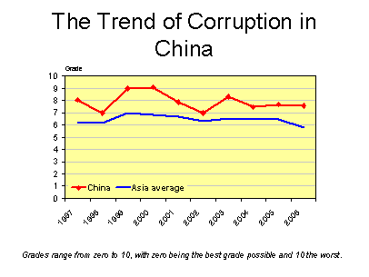
Dimensions of Corruption
Survey question | Average score
How serious do you consider the problem of corruption to be in the public sector?  Not serious 0-1-2-3-4-5-6-7-8-9-10 Very serious | 7.31
How serious do you consider the problem of corruption to be in the private sector?  Not serious 0-1-2-3-4-5-6-7-8-9-10 Very serious | 7.39
How effective is the judicial system at prosecuting and punishing individuals for corruption when abuses are uncovered?  0 = effective, 5 = effective but inconsistent, 10 = ineffective | 6.53
How serious is the government about fighting corruption?  0 = very serious, 5 = average, 10 = not serious at all | 4.88
How tolerant are average citizens of corruption?  0 = intolerant, 5 = moderate, 10 = extremely tolerant | 7.50
Do you perceive the trend of corruption to be decreasing, staying the same, or increasing?  0 = decreasing, 5 = staying the same, 10 = increasing | 3.13
To what extent is corruption a deterrent to your willingness to invest and expand your business?  0 = not at all, 5 = an average concern, 10 = a major deterrent | 5.81

HONG KONG
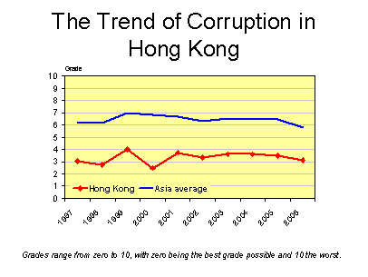
Dimensions of Corruption
Survey question | Average score
How serious do you consider the problem of corruption to be in the public sector?  Not serious 0-1-2-3-4-5-6-7-8-9-10 Very serious | 2.11
How serious do you consider the problem of corruption to be in the private sector?  Not serious 0-1-2-3-4-5-6-7-8-9-10 Very serious | 2.67
How effective is the judicial system at prosecuting and punishing individuals for corruption when abuses are uncovered?  0 = effective, 5 = effective but inconsistent, 10 = ineffective | 0.76
How serious is the government about fighting corruption?  0 = very serious, 5 = average, 10 = not serious at all | 1.04
How tolerant are average citizens of corruption?  0 = intolerant, 5 = moderate, 10 = extremely tolerant | 2.35
Do you perceive the trend of corruption to be decreasing, staying the same, or increasing?  0 = decreasing, 5 = staying the same, 10 = increasing | 3.13
To what extent is corruption a deterrent to your willingness to invest and expand your business?  0 = not at all, 5 = an average concern, 10 = a major deterrent | 2.96

INDIA
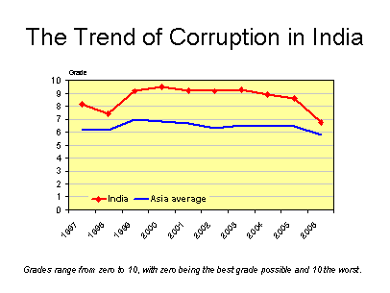
Dimensions of Corruption
Survey question | Average score
How serious do you consider the problem of corruption to be in the public sector?  Not serious 0-1-2-3-4-5-6-7-8-9-10 Very serious | 6.95
How serious do you consider the problem of corruption to be in the private sector?  Not serious 0-1-2-3-4-5-6-7-8-9-10 Very serious | 6.33
How effective is the judicial system at prosecuting and punishing individuals for corruption when abuses are uncovered?  0 = effective, 5 = effective but inconsistent, 10 = ineffective | 7.45
How serious is the government about fighting corruption?  0 = very serious, 5 = average, 10 = not serious at all | 7.00
How tolerant are average citizens of corruption?  0 = intolerant, 5 = moderate, 10 = extremely tolerant | 7.25
Do you perceive the trend of corruption to be decreasing, staying the same, or increasing?  0 = decreasing, 5 = staying the same, 10 = increasing | 3.92
To what extent is corruption a deterrent to your willingness to invest and expand your business?  0 = not at all, 5 = an average concern, 10 = a major deterrent | 5.77

INDONESIA
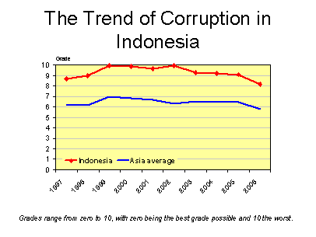
Dimensions of Corruption
Survey question | Average score
How serious do you consider the problem of corruption to be in the public sector?  Not serious 0-1-2-3-4-5-6-7-8-9-10 Very serious | 8.67
How serious do you consider the problem of corruption to be in the private sector?  Not serious 0-1-2-3-4-5-6-7-8-9-10 Very serious | 7.36
How effective is the judicial system at prosecuting and punishing individuals for corruption when abuses are uncovered?  0 = effective, 5 = effective but inconsistent, 10 = ineffective | 9.36
How serious is the government about fighting corruption?  0 = very serious, 5 = average, 10 = not serious at all | 8.73
How tolerant are average citizens of corruption?  0 = intolerant, 5 = moderate, 10 = extremely tolerant | 9.09
Do you perceive the trend of corruption to be decreasing, staying the same, or increasing?  0 = decreasing, 5 = staying the same, 10 = increasing | 3.64
To what extent is corruption a deterrent to your willingness to invest and expand your business?  0 = not at all, 5 = an average concern, 10 = a major deterrent | 8.36

JAPAN
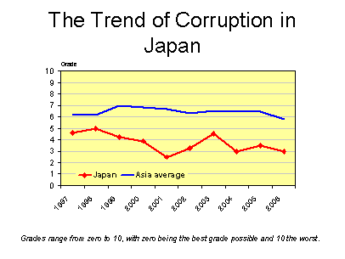
Dimensions of Corruption
Survey question | Average score
How serious do you consider the problem of corruption to be in the public sector?  Not serious 0-1-2-3-4-5-6-7-8-9-10 Very serious | 3.25
How serious do you consider the problem of corruption to be in the private sector?  Not serious 0-1-2-3-4-5-6-7-8-9-10 Very serious | 2.87
How effective is the judicial system at prosecuting and punishing individuals for corruption when abuses are uncovered?  0 = effective, 5 = effective but inconsistent, 10 = ineffective | 3.50
How serious is the government about fighting corruption?  0 = very serious, 5 = average, 10 = not serious at all | 3.11
How tolerant are average citizens of corruption?  0 = intolerant, 5 = moderate, 10 = extremely tolerant | 2.00
Do you perceive the trend of corruption to be decreasing, staying the same, or increasing?  0 = decreasing, 5 = staying the same, 10 = increasing | 3.78
To what extent is corruption a deterrent to your willingness to invest and expand your business?  0 = not at all, 5 = an average concern, 10 = a major deterrent | 2.44

MACAO
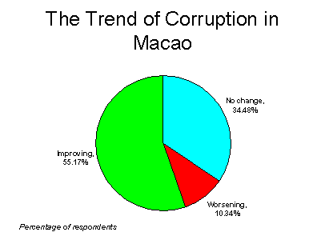
Dimensions of Corruption
Survey question | Average score
How serious do you consider the problem of corruption to be in the public sector?  Not serious 0-1-2-3-4-5-6-7-8-9-10 Very serious | 5.07
How serious do you consider the problem of corruption to be in the private sector?  Not serious 0-1-2-3-4-5-6-7-8-9-10 Very serious | 5.07
How effective is the judicial system at prosecuting and punishing individuals for corruption when abuses are uncovered?  0 = effective, 5 = effective but inconsistent, 10 = ineffective | 5.37
How serious is the government about fighting corruption?  0 = very serious, 5 = average, 10 = not serious at all | 4.64
How tolerant are average citizens of corruption?  0 = intolerant, 5 = moderate, 10 = extremely tolerant | 6.07
Do you perceive the trend of corruption to be decreasing, staying the same, or increasing?  0 = decreasing, 5 = staying the same, 10 = increasing | 3.70
To what extent is corruption a deterrent to your willingness to invest and expand your business?  0 = not at all, 5 = an average concern, 10 = a major deterrent | 4.43

MALAYSIA
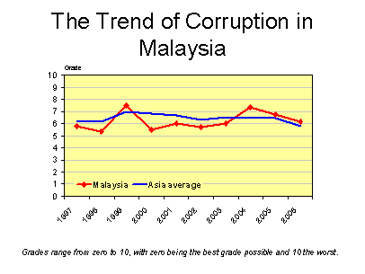
Dimensions of Corruption
Survey question | Average score
How serious do you consider the problem of corruption to be in the public sector?  Not serious 0-1-2-3-4-5-6-7-8-9-10 Very serious | 6.41
How serious do you consider the problem of corruption to be in the private sector?  Not serious 0-1-2-3-4-5-6-7-8-9-10 Very serious | 5.54
How effective is the judicial system at prosecuting and punishing individuals for corruption when abuses are uncovered?  0 = effective, 5 = effective but inconsistent, 10 = ineffective | 6.45
How serious is the government about fighting corruption?  0 = very serious, 5 = average, 10 = not serious at all | 6.36
How tolerant are average citizens of corruption?  0 = intolerant, 5 = moderate, 10 = extremely tolerant | 5.91
Do you perceive the trend of corruption to be decreasing, staying the same, or increasing?  0 = decreasing, 5 = staying the same, 10 = increasing | 3.73
To what extent is corruption a deterrent to your willingness to invest and expand your business?  0 = not at all, 5 = an average concern, 10 = a major deterrent | 4.82

PHILIPPINES
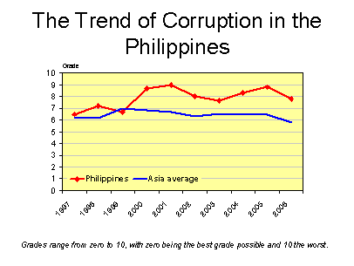
Dimensions of Corruption
Survey question | Average score
How serious do you consider the problem of corruption to be in the public sector?  Not serious 0-1-2-3-4-5-6-7-8-9-10 Very serious | 7.71
How serious do you consider the problem of corruption to be in the private sector?  Not serious 0-1-2-3-4-5-6-7-8-9-10 Very serious | 7.12
How effective is the judicial system at prosecuting and punishing individuals for corruption when abuses are uncovered?  0 = effective, 5 = effective but inconsistent, 10 = ineffective | 7.18
How serious is the government about fighting corruption?  0 = very serious, 5 = average, 10 = not serious at all | 8.18
How tolerant are average citizens of corruption?  0 = intolerant, 5 = moderate, 10 = extremely tolerant | 8.20
Do you perceive the trend of corruption to be decreasing, staying the same, or increasing?  0 = decreasing, 5 = staying the same, 10 = increasing | 6.07
To what extent is corruption a deterrent to your willingness to invest and expand your business?  0 = not at all, 5 = an average concern, 10 = a major deterrent | 7.73

SINGAPORE
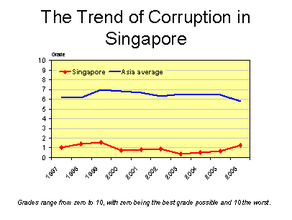
Dimensions of Corruption
Survey question | Average score
How serious do you consider the problem of corruption to be in the public sector?  Not serious 0-1-2-3-4-5-6-7-8-9-10 Very serious | 1.42
How serious do you consider the problem of corruption to be in the private sector?  Not serious 0-1-2-3-4-5-6-7-8-9-10 Very serious | 1.39
How effective is the judicial system at prosecuting and punishing individuals for corruption when abuses are uncovered?  0 = effective, 5 = effective but inconsistent, 10 = ineffective | 0.71
How serious is the government about fighting corruption?  0 = very serious, 5 = average, 10 = not serious at all | 0.57
How tolerant are average citizens of corruption?  0 = intolerant, 5 = moderate, 10 = extremely tolerant | 0.71
Do you perceive the trend of corruption to be decreasing, staying the same, or increasing?  0 = decreasing, 5 = staying the same, 10 = increasing | 3.36
To what extent is corruption a deterrent to your willingness to invest and expand your business?  0 = not at all, 5 = an average concern, 10 = a major deterrent | 1.50

SOUTH KOREA
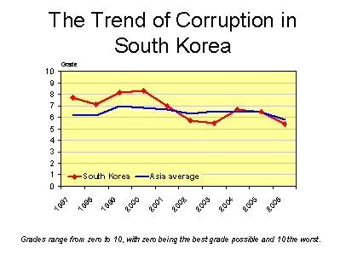
Dimensions of Corruption
Survey question | Average score
How serious do you consider the problem of corruption to be in the public sector?  Not serious 0-1-2-3-4-5-6-7-8-9-10 Very serious | 5.48
How serious do you consider the problem of corruption to be in the private sector?  Not serious 0-1-2-3-4-5-6-7-8-9-10 Very serious | 5.34
How effective is the judicial system at prosecuting and punishing individuals for corruption when abuses are uncovered?  0 = effective, 5 = effective but inconsistent, 10 = ineffective | 4.63
How serious is the government about fighting corruption?  0 = very serious, 5 = average, 10 = not serious at all | 4.56
How tolerant are average citizens of corruption?  0 = intolerant, 5 = moderate, 10 = extremely tolerant | 5.13
Do you perceive the trend of corruption to be decreasing, staying the same, or increasing?  0 = decreasing, 5 = staying the same, 10 = increasing | 3.44
To what extent is corruption a deterrent to your willingness to invest and expand your business?  0 = not at all, 5 = an average concern, 10 = a major deterrent | 5.22

TAIWAN
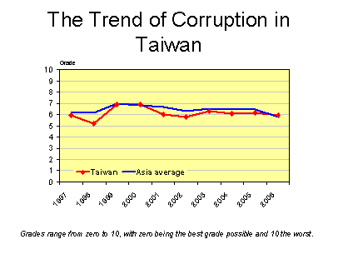
Dimensions of Corruption
Survey question | Average score
How serious do you consider the problem of corruption to be in the public sector?  Not serious 0-1-2-3-4-5-6-7-8-9-10 Very serious | 6.10
How serious do you consider the problem of corruption to be in the private sector?  Not serious 0-1-2-3-4-5-6-7-8-9-10 Very serious | 6.01
How effective is the judicial system at prosecuting and punishing individuals for corruption when abuses are uncovered?  0 = effective, 5 = effective but inconsistent, 10 = ineffective | 5.36
How serious is the government about fighting corruption?  0 = very serious, 5 = average, 10 = not serious at all | 5.36
How tolerant are average citizens of corruption?  0 = intolerant, 5 = moderate, 10 = extremely tolerant | 6.30
Do you perceive the trend of corruption to be decreasing, staying the same, or increasing?  0 = decreasing, 5 = staying the same, 10 = increasing | 4.73
To what extent is corruption a deterrent to your willingness to invest and expand your business?  0 = not at all, 5 = an average concern, 10 = a major deterrent | 5.91

THAILAND
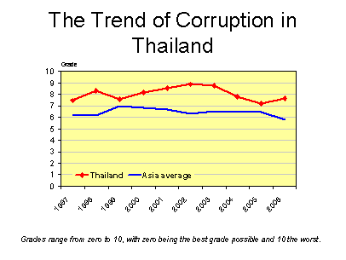
Dimensions of Corruption
Survey question | Average score
How serious do you consider the problem of corruption to be in the public sector?  Not serious 0-1-2-3-4-5-6-7-8-9-10 Very serious | 8.27
How serious do you consider the problem of corruption to be in the private sector?  Not serious 0-1-2-3-4-5-6-7-8-9-10 Very serious | 5.25
How effective is the judicial system at prosecuting and punishing individuals for corruption when abuses are uncovered?  0 = effective, 5 = effective but inconsistent, 10 = ineffective | 7.54
How serious is the government about fighting corruption?  0 = very serious, 5 = average, 10 = not serious at all | 8.00
How tolerant are average citizens of corruption?  0 = intolerant, 5 = moderate, 10 = extremely tolerant | 8.00
Do you perceive the trend of corruption to be decreasing, staying the same, or increasing?  0 = decreasing, 5 = staying the same, 10 = increasing | 7.14
To what extent is corruption a deterrent to your willingness to invest and expand your business?  0 = not at all, 5 = an average concern, 10 = a major deterrent | 5.54

VIETNAM
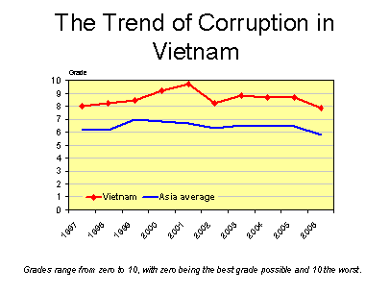
Dimensions of Corruption
Survey question | Average score
How serious do you consider the problem of corruption to be in the public sector?  Not serious 0-1-2-3-4-5-6-7-8-9-10 Very serious | 8.01
How serious do you consider the problem of corruption to be in the private sector?  Not serious 0-1-2-3-4-5-6-7-8-9-10 Very serious | 7.66
How effective is the judicial system at prosecuting and punishing individuals for corruption when abuses are uncovered?  0 = effective, 5 = effective but inconsistent, 10 = ineffective | 7.83
How serious is the government about fighting corruption?  0 = very serious, 5 = average, 10 = not serious at all | 8.57
How tolerant are average citizens of corruption?  0 = intolerant, 5 = moderate, 10 = extremely tolerant | 8.14
Do you perceive the trend of corruption to be decreasing, staying the same, or increasing?  0 = decreasing, 5 = staying the same, 10 = increasing | 4.29
To what extent is corruption a deterrent to your willingness to invest and expand your business?  0 = not at all, 5 = an average concern, 10 = a major deterrent | 8.57

EXCHANGE RATES ON 2/24/06
Chinese renminbi | 8.0430
Hong Kong dollar | 7.7581
Indian rupee | 44.3066
Indonesia rupiah | 9,294
Japanese yen | 116.863
Malaysian ringgit | 3.7145
Philippine peso | 52.0562
Singapore dollar | 1.6234
Korean won | 966.37
Taiwan dollar | 32.4886
Thai baht | 39.3701
Vietnamese dong | 15,911
Commercial middle rate expressed in terms of US$1.

Published by:
Political & Economic Risk Consultancy, Ltd.  20/F, Central Tower  28 Queen's Road, Central , Hong Kong  Mailing address: G.P.O. Box 1342 , Hong Kong | Tel: (852) 2541 4088  Fax: (852) 2815-5032  E-Mail: info@asiarisk.com  Web site: http://www.asiarisk.com
The material in this report may not be reproduced in whole or in part without permission in writing from the publisher. While every effort has been made to collate, check and present without ambiguity all data contained herein, the variety of sources from which they have been assembled and differing methods of reporting render verification oftentimes impossible. Thus, they are published without warranty.

