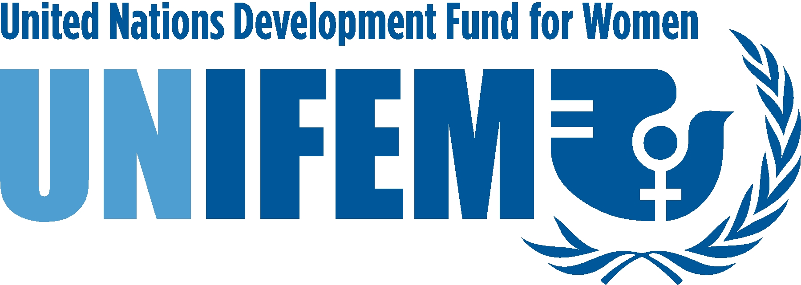

TERMS OF REFERENCE

GENDER, CORRUPTION, AND EFFORTS TO FIGHT CORRUPTION:
A PROPOSAL FOR A COMMISSIONED REVIEW

Context:
Corruption is costing the developing world billions of dollars every year. More importantly, it is a scourge that threatens and challenges all people around the globe, but bears with special cruelty upon the world's most poor. Corruption deepens poverty, debases human rights, degrades the environment, derails development, including private sector development; can drive conflict in and between nations, and destroys confidence in democracy and the legitimacy of governments.

Corruption is one of the main symptoms of poor governance, - a failure of institutions and or a break down of governance systems- and efforts to curb corruption constitute a major part of a range of good governance interventions. Corruption is hard to measure (it is a ‘consensual crime’ that does not get reported directly by those who suffer from it), but there is constant experimentation in measurement methods, indicators of corruption, and also efforts to measure its impact in terms of growth rates curbed or poverty reduction checked. A consistent feature of a number of anti-corruption measures is their relative lack of success, given the relative ease with which special anti-corruption commissions may be compromised by an unhelpful political appointee, or given the, in some contexts, ‘normalization’ of corruption and the difficulty of generating widespread civil society support for probity policies. This leaves good governance policy-makers with a number of dilemmas, including the on-going search for meaningful measures of corruption, the search for effective means of curbing it, and the challenge of generating civil society support for anti-corruption efforts.

In this context, there seems to be rather little space for considering what gender has to do with corruption or with reducing it. As a first step in clarifying these issues, UNIFEM and UNDP are coming together to commission an examination of the gendered dimensions of corruption. This could then lead to recommendations for increasing efforts of gender mainstreaming in programming and for better supporting women’s anti-corruption efforts, or making national anti-corruption institutions better able to curb the types of corruption that afflict women and girls.

Objective
The objective of the review would be to explore the gendered dimensions of corruption and of anti-corruption efforts, in particular as it relates to UNDP and UNIFEM projects with a view not only i) to improving understanding of the issues, but also ii) to guiding programming efforts that will make anti-corruption efforts more effective, and engage women in public probity struggles.

This review will be the fist step of a more global approach and project that will have to explore a number of the following perspectives:
- how gender shapes opportunities for engaging in corrupt exchanges
- how gender shapes the impact of corruption on women and men in terms of the types of resources that are denied to ordinary people owing to the ‘capture’ of public resources by power-holders;
- how gender shapes the very currency of corruption;
- how these gender dimensions of corruption should be captured in measurement systems;
- how women are involved in anti-corruption struggles.

Output
Under the direct supervision of the Anti-Corruption Adviser of the UNDP Democratic Governance Group (DGG) and the Governance Adviser of UNIFEM, and in consultation with the UNDP/DGG gender focal point, the consultant is expected to complete a review on corruption and anti-corruption and gender, based on the information. gathered according to the above and within the framework developed in the Practice Note for the sub-practice.

The consultant is expected to submit a main report with complete references and annexes if required

Specific tasks
The Consultant is expected to carry out the following tasks:

- Complete a literature review on corruption and gender of particular relevance to the UNDP/UNIFEM engagement in the field including the latest academic journals and research

- Review and analyze existing UNDP and UNIFEM anti-corruption programmes/projects in the period 2000 – 2005/6.

Qualifications
- Qualification and substantial experience in gender, development and governance,
- At least 3-5 years of work experience in development and gender issues , in particular the areas of Anti-Corruption and Public Administration reform
- Advanced university degree in gender and development, social sciences, development or international affairs or social sciences;
- Knowledge of UNDP and UNIFEM mission

Duration
The consultant is expected to complete the primer, starting May 1st and ending no later than May 30.

Location
The consultant is expected to work from home or own business location. No travel is required.

