Illicit Enrichment

By Narayan Manandhar

24 February 2012

THE public has applauded the recent court verdict convicting Nepalese Minister of Communication, Mr. J.P Gupta of corruption charges. The Supreme Court has reversed the earlier decision of the Special Court, which, in June 2007, had acquitted Mr. Gupta of corruption charges. The Commission for the Investigation of Abuse of Authority (CIAA) has filed the case in March 2003 and sought for Supreme Court review in November 2007. Mr. J. P. Gupta is the third person to be convicted of corruption charges under illicit enrichment. The other two people are Mr. Chiranjibi Wagle and Mr. Ramagya Chaturbedi who are currently serving their prison terms.

However, the much applauded court verdict could not escape public criticism. They are basically leveled on two counts. One, given his long tenure in important public positions, the punishment passed on to Minister Gupta is too liberal. It included 18 months of prison term plus the sum equivalent to doubling of Rs8.41million (about US$106,390) of property unaccounted for. Two, as there is a saying, justice delayed is justice denied. The verdict has come nearly after a decade. Going by the past records, a normal time for settling high profile corruption cases seems to be not less than ten years. If corruption charges are all about illicit accumulation of wealth and property, one can fairly imagine the time value of money within a decade. The value of Rs8.41 million in 2003 cannot be equal to Rs8.41 million in 2012. Unfortunately, time seems to stand still in our judicial system. That must be the reason why it takes ages to settle a case. There is one more ludicrous dimension to this case. As Mr. Gupta voluntarily surrendered to the court, because of an absurd legal system, he is entitled to have a bonus of 20 percent discount both in prison terms and monetary fines. This must be the reason why a convicted guy like Mr. Ramagya Chaturbedi was seen going to the prison with a big smile.

One specific feature of corruption crime is that it smells. One does not have to look into evidence; it just smells. In the case of Mr. Wagle, the odor came from the depositing of over Rs8 million (US$101,200) in the bank within a month for a series of land procurements; in the case of J.P Gupta, it is in the withdrawal of Rs5.5 million (US$69,576) from three banks, which, going by the court verdict, Mr. Gupta has failed to account for. When there is a shifting of a large sum of money within a short duration, there exists little chance of memory-loss unless one deliberately pretends to be ignorant.

Definitely, there is corruption involved in the case. However, what should be worrying is the method involved in arriving at corruption charges. I have referred earlier that the case of illicit enrichment is a hard nut to crack. It is a hard nut to crack in Nepal because of our extended family system, system of inheriting ancestral properties, informality in business operations, and the absence of scientific property valuation methods particularly of agriculture land and its produce.

The table below extracted from a 41-page long court verdict and CIAA charge sheet explains a wide difference in the valuation of property items and sources of income of Mr. Gupta. The top half of the table shows how valuation by CIAA differs with the valuations by the Special Court and the Supreme Court. If one reads the bottom line of the table, CIAA has brought a charge sheet of Rs20.8 million (US$263,124) as illicit enrichment, the Special Court has determined it to be a nominal figure of Rs700,000 (7%) (US$8,855) and hence acquitted Mr. Gupta of charges. The Supreme Court on the other hand has upheld the figure to be Rs8.41million and a sufficient ground for conviction. The wide differences in property valuations call for serious thinking in our approach to illicit enrichment. Most of the figures mentioned in the table are estimated or, at best, ‘guesstimated’ figures. I have no idea how much our legal pundits are comfortable with, with such figures.
 |  | Valuations (Rs)
 |  | CIAA | Special Court | Supreme Court
1 | Property Details
 | Land | 2,388,875 | 343,450 | 343,450
 | House | 5,113,647 | 2,280,411 | 2,280,411
 | Total Fixed Assets | 7,502,522 | 2,623,861 | 2,623,861
 | Vehicle | 2,463,016 | 1,800,000 | 2,463,016
 | Furniture | 801,191 | 400,595 | 400,595
 | Electronics | 182,000 | 182,000 | 182,000
 | Investment | 6,931,624
 | Bank Balance | 700,172 | 700,172 | 700,172
 | Deposit withdrawal | 5,556,752 | 5,361,365 | 5,361,365
 | Total Current Assets | 16,634,755 | 8,444,132 | 9,107,148
 | Educational Expenses | 195,387 | 195,387 | 195,387
 | Total Educational Expenses | 195,387 | 195,387 | 195,387
 | Grand Total | 24,332,664 | 11,263,380 | 11,926,396
2 | Sources of Income
 | Remuneration |  | 4,438,062 | 17,88,956
 | Foreign visits |  | 589,876 | 461,153.43
 | Sale of Jeep |  | 425,000 | 425,000
 | Car rent |  | 768,000 | 0
 | Sale of Car |  | 836,984 | 0
 | Land rent |  | 83,125 | 18,375
 | House rent |  | 422,700 | 105,675
 | Sale of Land |  | 275,766 | 275,766
 | Agriculture Income |  | 947,620 | 257,792.5
 | Mango Cultivation |  | 735,000 | 183,750
 | Bank Interest |  | 1,035,108 | 0
 | Total | 3,524,618* | 10,557,241 | 3,516,467.93
3 | Illicit Enrichment (1-2) | 20,808,046* | 706,139 | 8,409,928.07

*From the CIAA Charge Sheet.

Note: US$1 = Rs 79.05 (Source: Nepal Rastra Bank, http://nrb.org.np; accessed 24 Feb 2012.)

Interestingly, except for the valuation of the vehicle, there is no difference between the valuation of assets by the Supreme Court and the Special Court. But in the bottom half, with regards to determination of income sources, the CIAA valuation and the Supreme Court valuation are very close while the valuation by the Special Court diverts widely. If one reads the table carefully, three items have really cornered Mr. Gupta – (a) substantial undervaluation of remuneration; this is 38 percent less than what is evaluated by the Special Court, (b) non-recognition of income from renting and selling of the car supposed to be owned by Gupta as part of privileges allowed to MPs, and (c) non-recognition of interest income from the bank deposits that Gupta has failed to account for. In Nepali there is a saying pap dhuri bata karauchha (meaning, “the sin speaks from the sky”). This whole system of allowing MPs to import expensive vehicles without paying duties is in itself a corrupted invention in the first place. Therefore, it is no wonder that the sin is speaking loud and clear from the sky.

Let me end this write up with a profound idea now being floated in the field of anti-corruption. This could be an answer to our legal pundits asking for harsher penalties—some even calling for death sentences—to culprits convicted of corruption crimes. My answer is that: had the death sentence been an answer to checking corruption crime, today, China and Vietnam should be the cleanest countries in the world. Unfortunately, both countries are ranked as the most corrupt countries.

Reading the psychology of corrupt people, anti-corruption experts are now saying that what worries corrupt people most about their crime and its detection is the fear of confiscation of property they have amassed through corrupt means. A prison term does not worry them; they are not even worried by a possible death sentence. If this is the psychology of corrupt people then our penal system should be designed so that we an extract maximum resources from the convicts.

We need to do away with this system of doubling of fines and additional imprisonment. Given the scale of damages and the time involved in settling the cases, these are peanut punishments. Probably, we need a system, say, a penalty imposing fines of 100 times more than the amount involved. Only such a system will help to deter corruption crime. The current system of giving a discount for voluntary surrender is a sheer mockery in our judicial system.

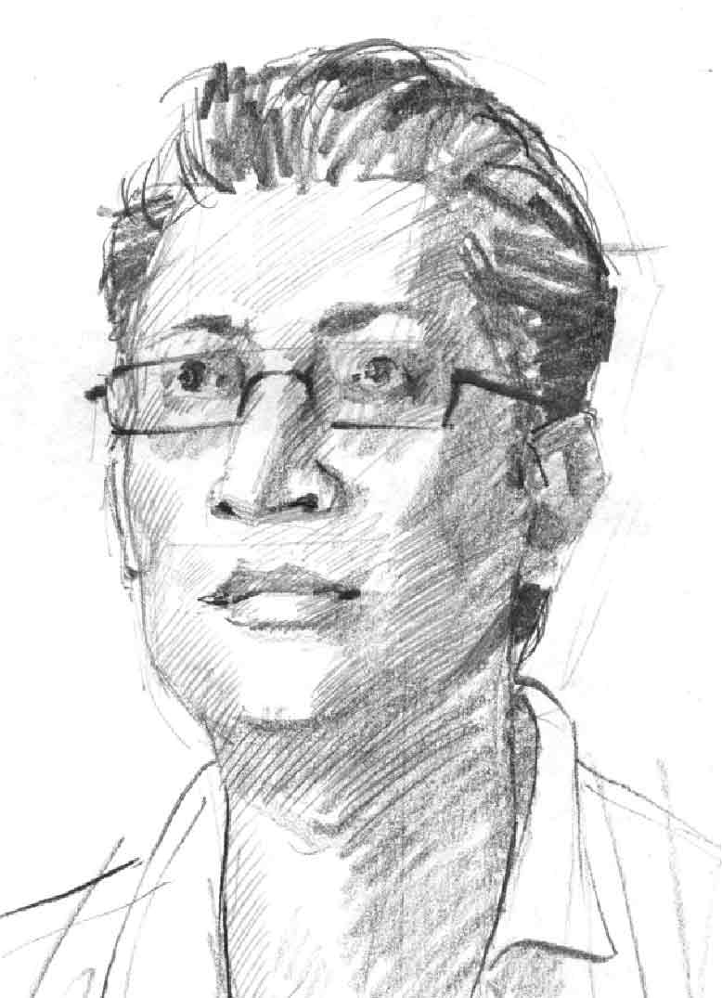
About the author
Dr. Narayan Manandhar has been involved in anti-corruption work in Nepal since 2004. He is a former Anti-Corruption Advisor to the Danish International Development Agency (Danida) Programme on Human Rights and Governance in Nepal. He is now a freelance consultant in the field of governance and anti-corruption. Dr. Manandhar has written more than 100 articles on corruption and anti-corruption issues in Nepalese newspapers. He has presented his views in numerous seminars, workshops, and TV and radio interviews. He is currently working with UNDP’s Asia-Pacific Regional Centre on a regional study on measuring corruption and monitoring and evaluation of national anti-corruption strategies.

