Liberia Peacebuilding Fund

QUARTERLY STATUS UPDATE AS OF DECEMBER 31, 2009

Recipient UN Organization: | UNDP |  | PBF Priority Area: |  | Critical Interventions to Promote and Resolve Conflict
Implementing Partner(s): | Liberia Anti-Corruption Commission (LACC)
Project Number: | PBF/PP/R5/A3/01 (PBF/LBR/E-8)
Project Title: | Supporting the Liberia Anti-Corruption Commission
Total Approved Project Budget | $500,000
Project Objective and Scope | The underlying objective of the project is catalytic, that is, to respond the immediate need of the Commission to achieve functionality as key institution of good governance,  by investigating allegations of corruption, building operational and public engagement capacity, and deterring corruption. The project, “Supporting the Liberia Anti-Corruption Commission (LACC)” seeks to address the challenges of corruption that threaten peace in Liberia, by fostering democratic governance—good governance through the establishment of an integrity system in government, to enhance transparency and accountability in the management of state resources and assets. The scope of the project is the fifteen counties of Liberia.
Funds Committed: | $500,000 |  | Percentage of Approved: |  | 100%
Funds Disbursed: | $317, 355. 00 |  | Percentage of Approved: |  | 63.47%
SC Approval Date: | 22 March 2009
Expected Project Duration: | 18 Months | Forecast Final Date: |  | September 2010 |  | Delay (Months): | Three Months

Outputs: | Progress: | Percentage of planned:
The services of professionals / firm hired to handle computer networking and maintenance services and to provide consultancy in enhancing the LACC’s functionality and effectiveness as regards technology. | The construction of LACC’s website, wiring/cabling and networking components, alongside the instillations of servers, anti-virus software has been completed. In addition, a computerized database system for the Commission’s Investigation Unit has been established. | 100%
Public awareness enhanced and deterrence fostered through the establishment of nationwide anti-corruption radio talk shows. | Under the supervision of the Public Relation Officer of LACC eighteen of the twenty-four anti-corruption radio talk shows across the nation have been conducted, discussing activities/ issues of the Commission as it relates to the enhancement of governance-accountability, transparency, peace, and the building of an integrity system. | 75%
Public awareness enhanced and deterrence fostered through the establishment of nationwide anti-corruption television talk shows. | Under the supervision of the Public Relations Officer of LACC, eighteen of the twenty-four lived on TV anti-corruption talk shows across the nation are completed, discussing issues/ activities of the Commission as it relates to the enhancement of governance-accountability, transparency, peace, and the building of an integrity system. | 75%

Outcomes: | Progress:  {In terms of Indicators} | Comments/Remarks:
Enhanced public awareness and sensitization across Liberia through print and promotional materials. | Citizens’ awareness enhanced and increased knowledge and understanding amongst stakeholders of the acts creating the Commission, policy, regulations and strategies of LACC through the airing of radio talk shows on LACC and its role in good governance. More persons understand the role and mandate of LACC | Not all of the printed materials were fully utilized as some of the printed materials will be used for future anti—corruption engagements/ events.
Logistical and institutional support provided to enhanced the technical capacity and operationalize the Commission’s functionality. | LACC technical capacity to under its mandate strengthened by d installing computer server and monitor, providing technical capacity development training to staffers of LACC on the usage of installed technology and service. | Support was based upon the recommendations made by the contracting firm, and at the request of LACC.
Enhanced transparency and public awareness through the publication of the “Declaration of Assets and Liabilities forms” | Fostered transparency and public awareness by publishing and disseminating in print media, countrywide, the Declaration of Assets, and Liabilities forms for public leaders. | This activity was conducted during the third and fourth quarters (July- December 2009) of implementations.

Qualitative achievements against expected results:
Key Outputs Achieved

CSOs, media and stakeholders regularly engaged and relationship strengthened through the ongoing anti-corruption radio and television talk shows, deterrence enhanced by investigating allegations of corruption and strategies established by establishing its 3-Year Plan of Action (POA), also known as three-year strategy work plan for LACC. In addition, at the nucleus of its existence, the LACC has made momentous strides leading to the establishment of frameworks critical to the exhibition of a high sense of integrity, accountability and transparency, as a way of alleviating public discontent and of course, rebuilding confidence in good governance that would ultimately guarantee peace and stability in Liberia. The LACC is now functional with the installation of technology to enhance the investigation of corruption cases, computer networking service enhanced, websites constructed to promote public awareness, report alleged corruption cases and, has in recent times embarked upon the investigation of a few alleged corruption cases, involving the Hon. Minister of Gender, the suspended Hon. Minister of Information, Culture and Tourism, etc. Overall, elements of democracy, accountability and transparency and ownership are all being maximized by allowing stakeholders, including citizens across Liberia to participate in the fight against corruption—through the LACC’s live call-ins radio and television shows, stakeholder s and citizens are able to participate and contribute in national issues and partake in the fight against corruption nationally.

Next Steps:

Local Staff member training:
The Trinity Computer Solutions, in coordination with LACC, established and conducted a series of training for staffers of the LACC on the use of installed technology, including software, networking and data assessment, etc. The training was done comprehensively and included the Executive Chairperson, the Commissioners, the Executive Director, and others, all of whom are expected to expand their knowledge and experiences.

Activities planning: Now that the LACC has prepared and submitted its three-year POA for latent consideration, the commission has shall continue its public awareness campaigns on anti-corruption in the remaining counties across Liberia. There is an additional plan to provide support for the elaboration of an MoU between LACC on the one hand, and the MoJ, GAC and other law enforcement agencies on the other hand.

Challenges{If Necessary}:
It has been suggested that to resources and time, that the LACC ensures that planned county forums are conducted by clustering counties that are in the same region, as opposed to conducting the county forum county-by-county.

Annex 1 List of key individuals/ participants consulted (October-December, 2009)

Executive Chairperson Frances Johnson Morris
Hon. Daniel B. Tipayson, Executive Director- LACC
Ben Kolako, Public Relations Officer- LACC
Mr. David Korlea, President, Trinity Computer Solutions
Mr. John Kollie, Executive Director- Liberia Media Initiatives (LMI)
Maria-Threase Keating, UNDP
SRSG Ellen Loej, UNMIL
Dominic Sam, UNDP
Nessie Golokai, UNDP
William Kpanah Gowah Barnes- UNDP
Renuka Chidambarah, UNMIL , Director for Rule of Law
Chirstopher Anderson, UNDP, Deputy Country Director
Fatumata Sheriff, Assistant Minister of Justice
Frank Loboe, TV 8, 99.8 FM
Cecelia Danuweli, WIPNET
Wilfred Gray-Johnson- UN Peace Building Fund
Jerome Hanson, UN Peace Building Fund
Ms. Tracy Johnson, U.S. State Department
Lancedell Matthews, CSO
Janet S. Sar

Annex II: Photos of PBF funded activities (October- December, 2009)

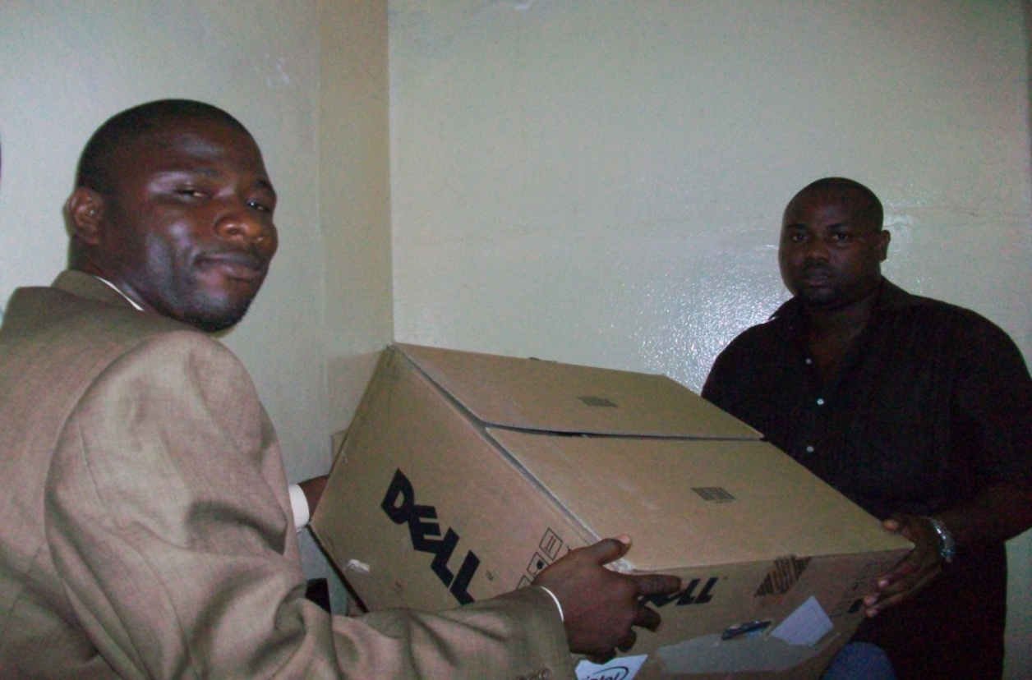
Dr. William K.G. Barnes of UNDP presenting the server to Mr. Dalmon Cooper, LACC’s Procurement/ Logistics Officer
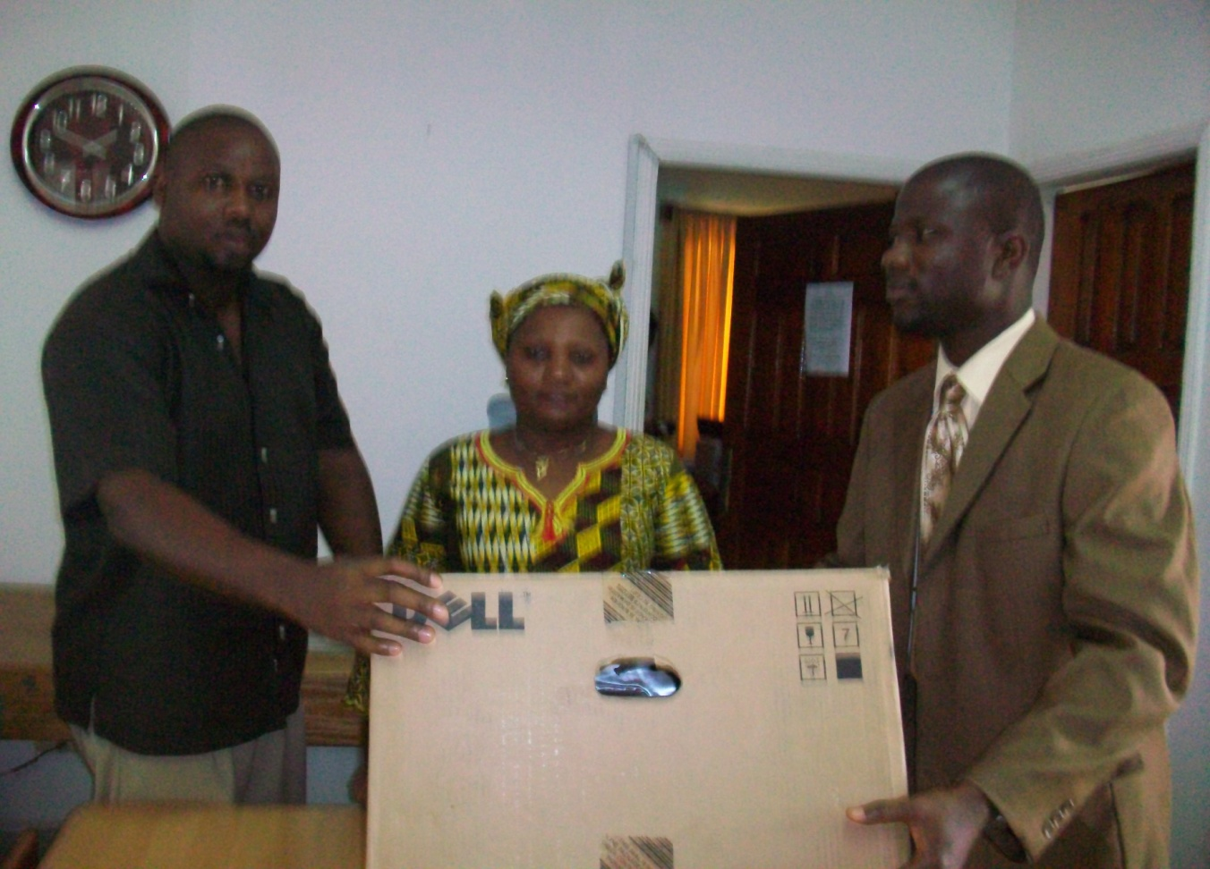
Dr. William K.G. Barnes of UNDP presenting the server (monitor) to Mr. Dalmon Cooper and a staff of LACC

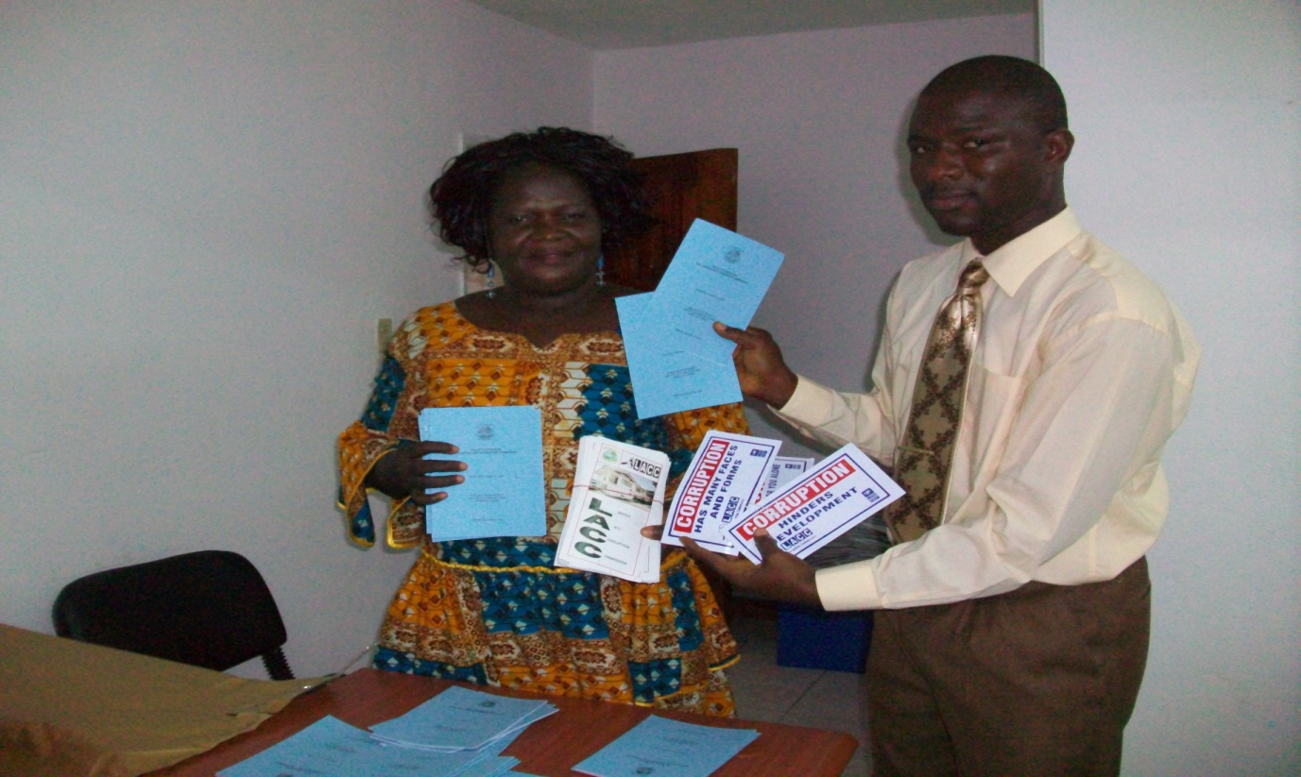
Madam Janet S. Sarsih, Programme Manager for Education and prevention of LACC and Dr. Barnes of UNDP displaying assorted printed anti-corruption materials

Annex III: List of Abbreviations and Acronyms

AU…………………………………………………………………..African Union

AWP……………………………………………………….….Annual Work Plan

CENTAL…………….Centre for Transparency and Accountability in Liberia

CSOs……………………………………………….Civil Society Organizations

DEX……………………………………………………………..Direct Execution

GC……………………………….............................Governance Commission

GOL............................................................................Government of Liberia

IMF………………………………………………..International Monetary Fund

LACC…………………………………...Liberian Anti-Corruption Commission

MOU…………………………………….……Memorandum Of Understanding

NPRS……………………………………National Poverty Reduction Strategy

PBF…………………………………………………..……Peace Building Fund

TOR……………………………………………..…………Terms Of Reference

UNDP……………………………..United Nations Development Programme

UNMIL………………………………………United Nations Mission in Liberia

USAID………………..United States Agency for International Development

ULSU…………......................................University of Liberia Student Union

