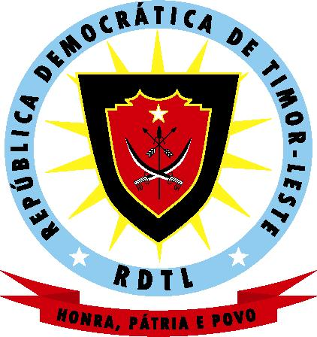

DEMOCRATIC REPUBLIC OF EAST TIMOR

MINISTRY OF INTERNAL ADMINISTRATION
Civil Service Commission

C O D E O F E T H I C S

Considering that the East Timor civil servants play an important role among the East Timor community in order to guarantee a good quality of services rendered by the Public Administration, in an effective and efficient manner, to all citizens in general;

Acknowledging that in the past corruption, nepotism, indiscipline and the lack of responsibility in fulfilling the legal determinations established dominated all sectors of the public administration, involving the civil servants as agents of this same administration;

Having become necessary to provide for the establishment of regulatory norms for the actions of the East Timor civil servants, as a determining factor for the existence of an administration system that is open, transparent and highly respecting of human rights and the principles of democracy;

The East Timor civil servant, in the name of the Nation and in memory of all those that sacrificed themselves for its liberation and independence, pledges to:

- Look after the Country’s higher interests, whereby interests of the East Timor people mean defending their independence, complying with the laws in general and those related to the civil service, and respect the moral and cultural values of the East Timor people;

- Respect and seek to implement all the ratified national and international conventions and promote the respect for human rights, the authority of the law and democratic principles;

- Be a model of personal integrity, authenticity and honesty, always, and in everything, seeking to contribute to the civil service’s good reputation in all his/her actions;

- Serve the public with courtesy and dedication, placing the public interest above any personal interest;

- Follow only those directives and instructions duly outlined by his/her superiors and reject any instructions or attempts, by any institution or individual outside of the East Timor Public Administration, from influencing his/her official actions;

- Comply with the law and honour his/her private obligations, including the obligation to honour the orders of the East Timor Courts.

- Serve the public without any form of discrimination or intimidation, including sexual or of the kind, verbal or physical abuse on the spot or related to work;

- Reject any threat, intimidation or conduct with the direct or indirect intention of interfering with the mission of the East Timor Public Administration;

- Duly explain his/her tasks, category and the nature of his/her tasks in the East Timor Public Administration to individuals outside the Administration;

- Reject any favour, offer or remuneration, or any other official gift that may be offered in exchange for the execution or omission of any official act;

- Use the property belonging to the East Timor Administration or the information obtained in his/her official capacity solely for activities related with his/her official tasks and obligations;

- Reveal any direct or indirect benefit that he/she may have in any lucrative activity, business or company that is under his/her tasks or duties, to the Administration;

- Exercise his duties with zeal, intelligence and aptitude, seeking to perfect him-/herself by means of training courses or others for the evermore efficient execution of the tasks inherent to his duties;

- Contribute to the consolidation of national unity as a determining factor for the economic and social development of East Timor.

This Code of Ethics is effective as from ___ ____________, 2000.

Seen and approved by

